# Preguntas Objetivo 3

## Pregunta 1

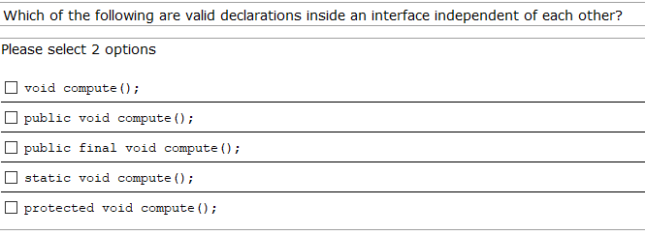

## Pregunta 2

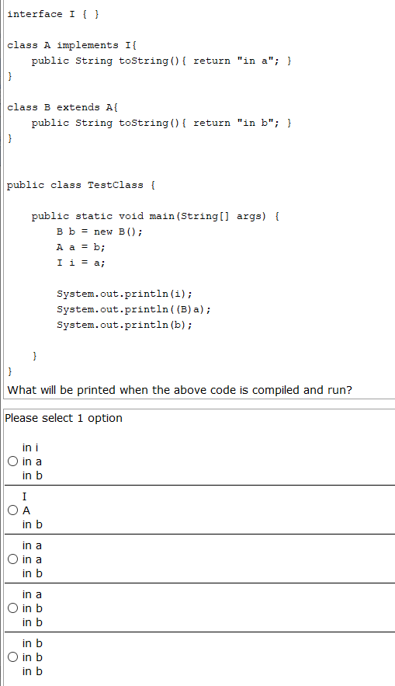

## Pregunta 3

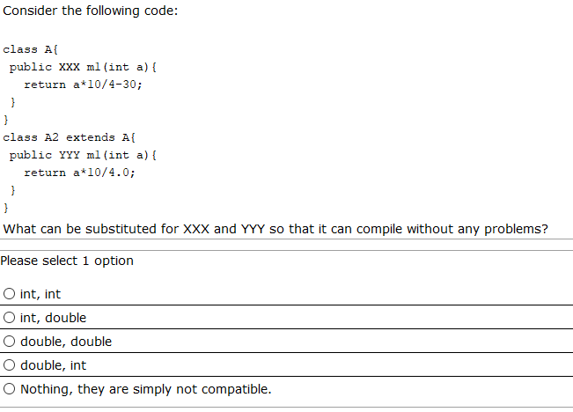

## Pregunta 4

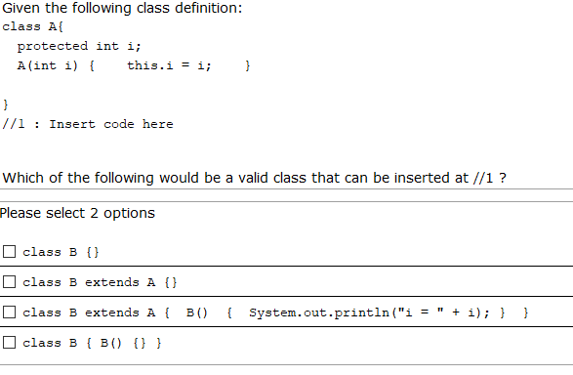

## Pregunta 5

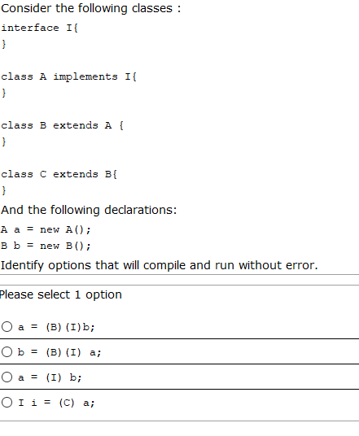

## Pregunta 6

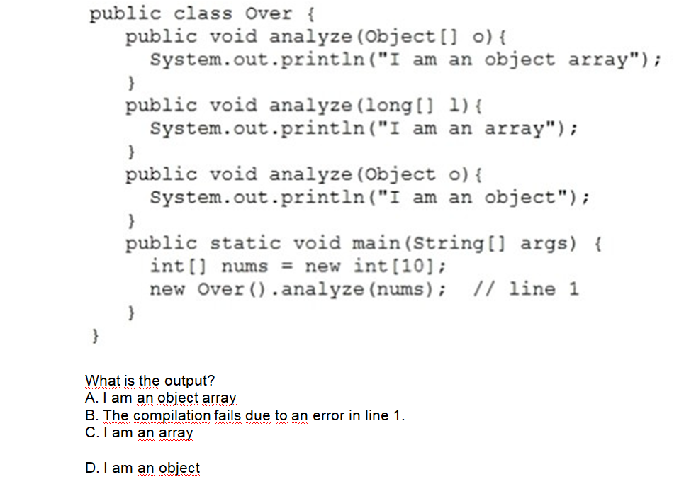

## Pregunta 7

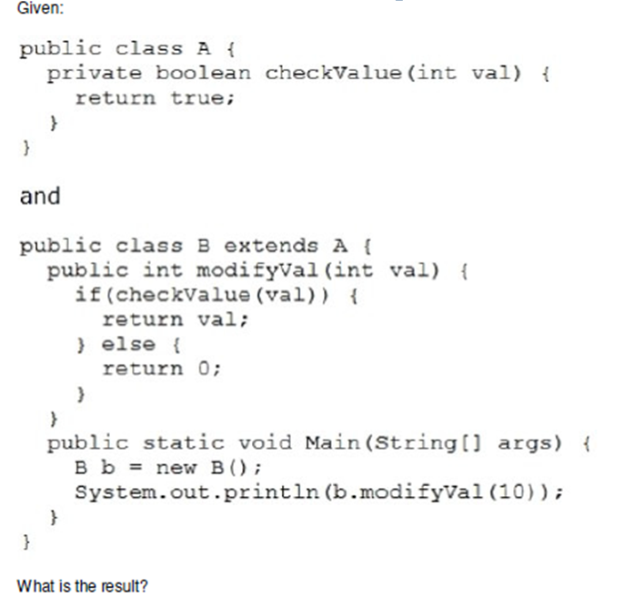

A. nothing

B. It fails to compile.

C. 0

D. A java.lang.IllegalArgumentException is thrown.

E. 10

## Pregunta 8

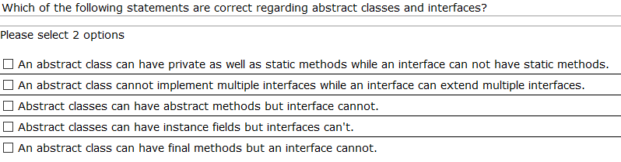

## Pregunta 9

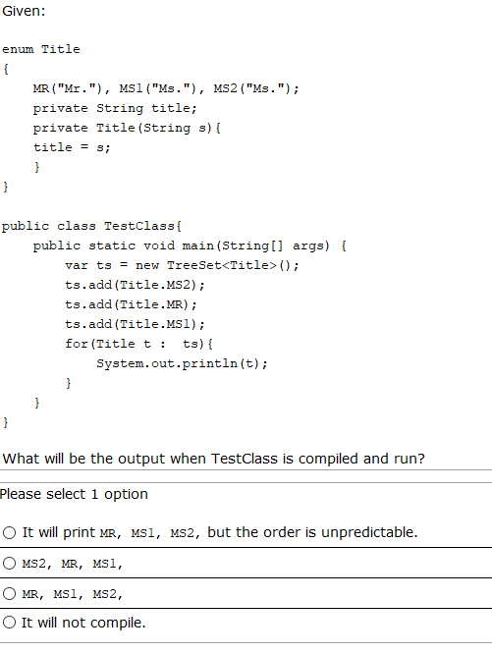

## Pregunta 10

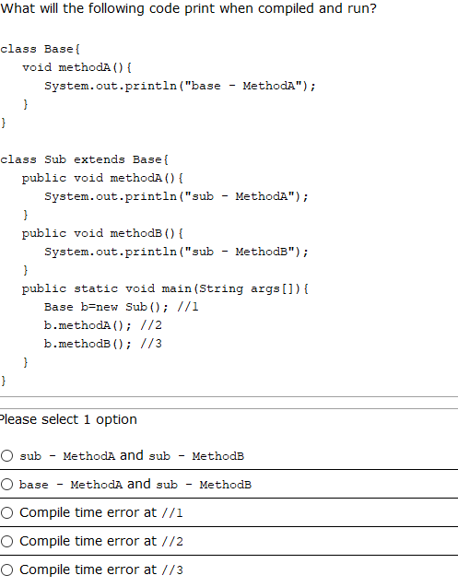

## Pregunta 11

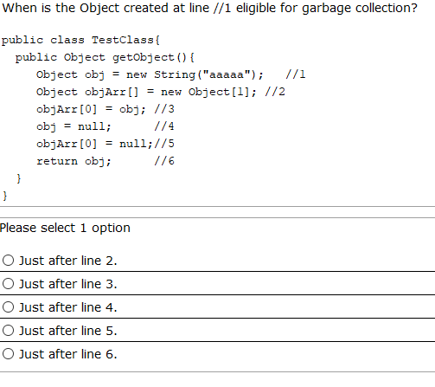

## Pregunta 12

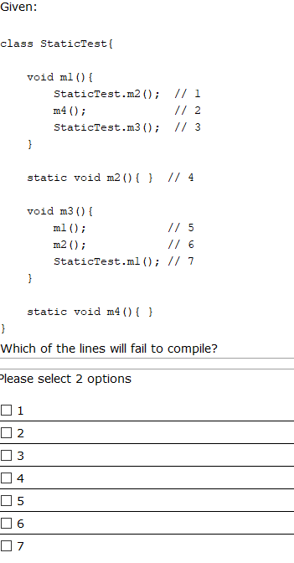

## Pregunta 13

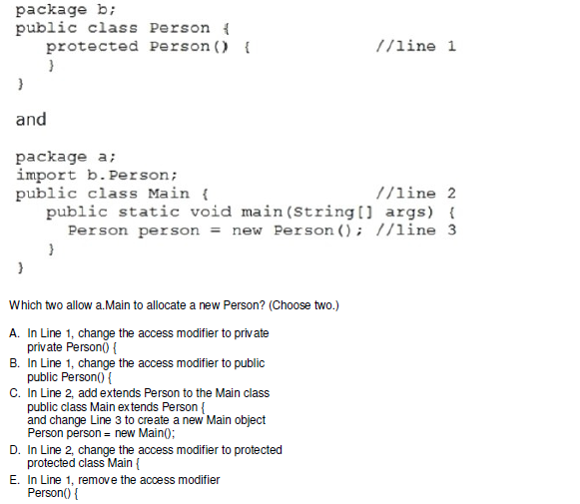

## Pregunta 14

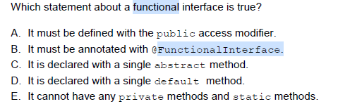

## Pregunta 15

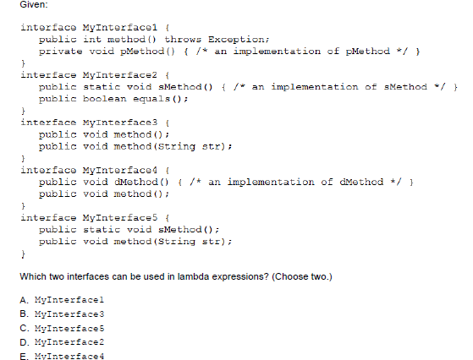

## Pregunta 16

Given the following

class Test{

int a;

static int b;

static{

b++;

}

Test(){

while(a<5){

b++;

a++;

}

}

public static void main(String[] args){

Test t1=new Test();

Test t2=new Test();

System.out.println(t1.a+":"+t2.b);

}

}

Which is the result?

A. 10:10

B. 5:10

C. 5:11

D. 11:5

E. Compilation fails

## Pregunta 17

Given:

C1.java

package p1;

public class C1{

int p;

private int k;

public int s;

protected int x;

}

C2.java

package p2;

import p1.C1;

public class C2{

public static void main(String[] args){

C1 obj=new C1();

}

}

Which statement is true?

1. Both p and s are accesible by obj
2. p, s and x are accesible by obj
3. Only s is accesible by obj
4. Only x is accesible by obj
5. Both x and s are accesible by obj
6. C. None of the variables are accesible by obj

## Pregunta 18

Given the following:

public class Test {

public Test(){

System.out.println("No params");

}

public void Test(int j){

System.out.println("Param "+j);

}

public static void main(String[] args) {

Test t=new Test(3);

}

}

Which is the result?

A. Param 3

B. No params

C. Compilation fails

D. Exception

## Pregunta 19

Consider the following code:

class MyClass { }

public class TestClass{

MyClass getMyClassObject(){

MyClass mc = new MyClass(); //1

return mc; //2

}

public static void main(String[] args){

TestClass tc = new TestClass(); //3

MyClass x = tc.getMyClassObject(); //4

System.out.println("got myclass object"); //5

x = new MyClass(); //6

System.out.println("done"); //7

}

}

After what line the MyClass object created at line 1 will be eligible for garbage collection?

A. 2

B. 5

C. 6

D. 7

E. Never until the program ends

## Pregunta 20

What will be the contents of s1 and s2 when the control reaches the println statement in the main method of the following program?

import java.util.*;

public class TestClass{

public static void main(String args[]){

Stack s1 = new Stack ();

Stack s2 = new Stack ();

processStacks (s1, s2);

System.out.println (s1 + " "+ s2);

}

public static void processStacks(Stack x1, Stack x2){

x1.push (new Integer ("100"));

//assume that the method push adds the passed object to the stack.

x2 = x1;

}

}

A. [100][100]

B. [100][]

C. [][100]

D. [][]

## Pregunta 21

Given the following pairs of method declarations, which of the statements are true? (choose 2)

1.

void perform_work(int time){ }

int perform_work(int time, int speed){ return time*speed ;}

2.

void perform_work(int time){ }

int perform_work(int speed){return speed ;}

3.

void perform_work(int time){ }

void Perform_work(int time){ }

A. The first pair of methods will compile without errors and they correctly demonstrate method overloading

B. The second pair of methods will compile correctly and overload the method 'perform_work'

C. The third pair of methods will compile correctly and overload the method 'perform_work'

D. The second pair of methods will not compile correctly

E. The third pair of methods will not compile correctly

# Pregunta 22

Given:

class Base{

public List<CharSequence> transform(Set<CharSequence> list){

//valid code

};

}

class Derived extends Base{

*INSERT CODE HERE*

//valid code

}

}

What can be inserted in the above code?

A. public List<String> transform(Set<String> list){

B. public List<Object> transform(Set<CharSequence> list){

C. public ArrayList<CharSequence> transform(Set<CharSequence> list){

D. public List<StringBuilder> transform(Set<CharSequence> id){

E. public List<Integer> transform(TreeSet<CharSequence> id){

F. public ArrayList<String> transform(Set<String> id){

# Pregunta 23

Consider the following classes...

class Teacher{

void teach(String student){

/* lots of code */

}

}

class Prof extends Teacher{

//1

}

Which of the following methods can be inserted at line //1 ?

A. public void teach() throws Exception

B. private void teach(int i) throws Exception

C. protected void teach(String s)

D. public final void teach(String s)

E. public abstract void teach(String s)